**Boston University**

**Electrical & Computer Engineering**

**EC463 Senior Design Project**

First Semester Report

NeuroToys: Non-Invasive Brain Computer Interface for Real-Time Robot Control

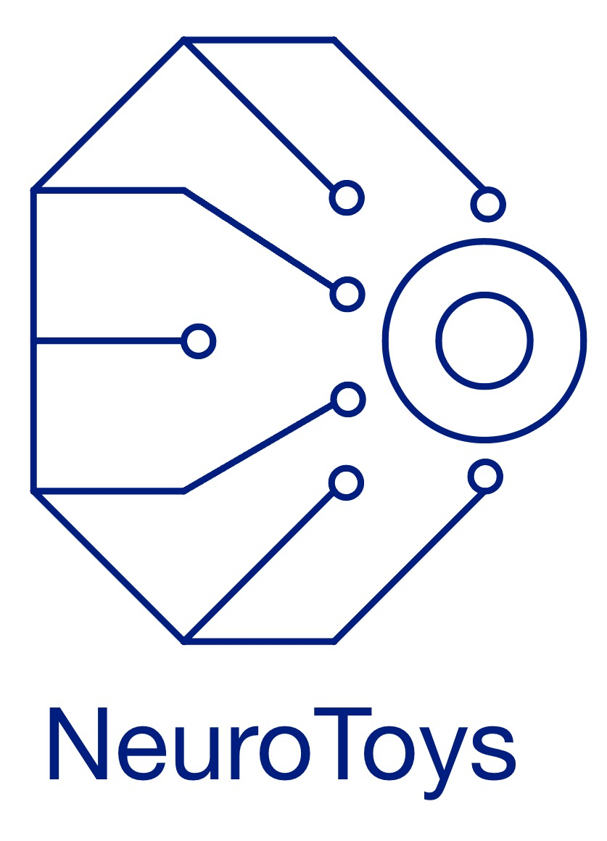

Submitted to

Prof. Ryan Lagoy

8 St. Mary’s Street Boston, MA 02215

(617) 353-6264

rclagoy@bu.edu

by

Team 9

NeuroToys

Adam Shaikh [adamparz@bu.edu](mailto:adamparz@bu.edu)

Andrés Marquez Santacruz [afms@bu.edu](mailto:afms@bu.edu)

Gabriela Porto Machado [gmpm@bu.edu](mailto:gmpm@bu.edu)

Mete Gumusayak [mgumus@bu.edu](mailto:mgumus@bu.edu)

Robert Bona [rjbona@bu.edu](mailto:rjbona@bu.edu)

Submitted: 12/07/2024

#### Table of Contents

Executive Summary 3

1.0 Introduction 1

2.0 Concept Development 2

3.0 System Description 4

4.0 First Semester Progress 7

5.0 Technical Plan 7

6.0 Budget Estimate 9

7.0 Attachments 10

7.1 Appendix 1 – Engineering Requirements 10

7.2 Appendix 2 – Gantt Chart 11

# 

# Executive Summary

Non-Invasive Brain-Computer Interface for Real-Time Robot Control

Team 9 – NeuroToys

This project aims to revolutionize human-machine interaction by enabling control of a robotic device using brain signals. It addresses the challenge of enabling individuals, particularly those with mobility impairments, to control devices effortlessly and intuitively using their brain activity. Traditional device control methods such as joysticks and remotes are restrictive and often inaccessible. Using Electroencephalography (EEG) signals, NeuroToys aims to create a non-invasive brain-computer interface (BCI) that translates brainwave patterns into real-time motor commands for a car toy.

The final deliverables will include a fully functional robotic device controlled by EEG signals, a software interface for real-time feedback, and a user-friendly graphical interface for calibration and monitoring. The system will incorporate robust signal processing, achieving 95% noise reduction and a command recognition accuracy exceeding 85% after calibration. The portability and wireless nature of the system ensure ease of use with a communication range of at least 10 meters.

The proposed technical approach integrates machine learning for signal interpretation classification, dynamic threshold calculation for real-time command interpretation, and innovative hardware design. NeuroToys features a low-cost, portable, and user-friendly EEG system optimized for comfort and usability. This solution not only fosters greater independence for individuals with disabilities but also opens pathways for applications in healthcare, rehabilitation, and entertainment, contributing to the advancement of accessible human-machine interaction technologies

# Introduction

Individuals with physical disabilities often face significant challenges in controlling devices and interacting with technology, relying on manual inputs or invasive surgeries that may be inaccessible or impractical. For customers seeking accessible solutions, NeuroToys addresses this critical need for user-friendly and non-invasive technologies that enable effortless control of devices through thought alone. This initiative represents a critical step towards the advancements of human-machine interaction, offering an intuitive and inclusive solution for users with mobility impairments and other physical limitations.

Thus, as customers seek solutions to enable device control for users with mobility impairments and encounter shortcomings due to traditional inaccessible, invasive, and costly ways, this project seeks to demonstrate the feasibility of neural-based robotic control while ensuring accessibility, affordability, and ease of use for diverse applications.

To achieve this, NeuroToys leverages Electroencephalography (EEG) technology to capture brainwave signals, which can be gathered through an external headgear. By processing and classifying this neural activity in real time, the system translates them into actionable commands for a robotic toy. This project integrates hardware, such as the NeuroSky Mindwave Mobile 2 headset and an ESP-WROOM-32 microcontroller, with software built on Python for signal processing and command execution. The ultimate goal is to provide a seamless, wireless, and portable solution that bridges the gap between user intent and device functionality.

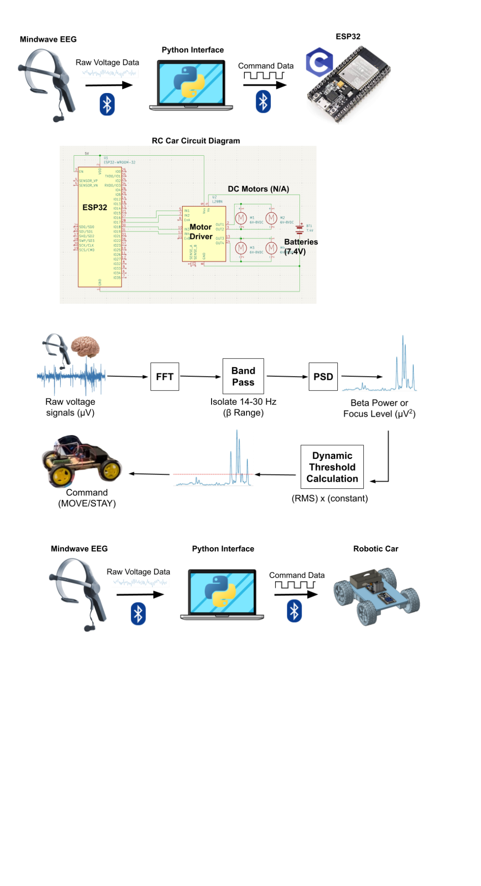

**Figure 1. Neurotoys current system architecture, showcasing an integration of EEG signal acquisition, real-time processing, and robotic control**

Key highlights of the project include its focus on accessibility, with reduced setup complexity and cost compared to existing alternatives. The lightweight and portable nature of our set up enhances usability, its classification methods allow for advanced motor control. In addition, it is designed to be cost-effective, making it an affordable solution for a broader audience. NeuroToys is not only a type of assistive technology, but also a foundation for broader applications, such as rehabilitation, smart home automation, and gaming.

Thus, through an interdisciplinary approach and user-centric design, we offer an modern, accessible, and affordable solution that redefines the way people interact with technology, empowering users and advancing the field of human-machine interaction.

# Concept Development

## Customer's Problem

The customer seeks to address the accessibility challenges faced by individuals with mobility impairments. Traditional methods of device control, such as joysticks and remote controls, are often impractical or inaccessible to these users. Additionally, existing brain-computer interface (BCI) solutions tend to rely on invasive surgeries or cumbersome setups, creating barriers to widespread adoption.

Thus, this project requires a system that enables seamless, non-invasive, and real-time control of a robotic toy using brainwave signals, ensuring portability, accuracy, and affordability for its users.

## Engineering Requirements

To meet these needs, we developed a set of engineering requirements focused on usability, performance, and functionality. The system must be compact, with the robotic toy limited to dimensions of 12in x 8in x 6in to ensure portability. It must operate for at least two hours on a single charge and maintain a wireless communication range exceeding 10 meters for flexibility in user interaction.

To enhance user experience, setup time is constrained to under five minutes, with classification accuracy exceeding 80% over five 30-second trials for reliable performance. Finally, total system latency must remain below 500 milliseconds to support real-time responsiveness.

These requirements, detailed in Appendix 1, ensure that the solution aligns with the customer’s accessibility goals and practical considerations.

## Conceptual Approach

To solve the customer’s problem, our conceptual approach integrates Electroencephalography (EEG) technology with real-time signal processing and machine learning algorithms. The NeuroSky Mindwave Mobile 2 EEG headset captures brainwave signals, which are processed and classified in Python. The processed signals are then transmitted wirelessly to an ESP-WROOM-32 microcontroller that controls the robotic toy's movements. This system architecture ensures a lightweight, portable, and cost-effective solution.

The decision to use EEG was driven by its ability to measure brain activity associated with intention, providing an intuitive method for control. By filtering the raw voltage signals to show only the focus/alertness frequency range, we were able to ensure accurate classification of user commands. The system’s modular design also enables future scalability like multi-directional movement and more complex commands.

## Alternative Solutions Considered

## Electromyography (EMG) - based control

EMG measures electrical signals generated by muscle activity and could be used to send commands to an external device. During early design discussions, we considered placing EMG sensors on the wrist to detect finger motions as control signals for the robotic toy. For example, specific finger movements, such as tapping or flexing, could be mapped to directional commands (e.g., forward, left, right).

While this approach is non-invasive and provides reliable signal acquisition, it still adds limitations for individuals with limited muscular control, such as those with neuromuscular diseases or paralysis. Additionally, interpreting these subtle muscle signals consistently across users introduced challenges in accuracy and usability. To make our solution as accessible as possible, we prioritized a system that could operate independently of muscle activity.

## fNIRS - based control

We also considered functional Near-Infrared Spectroscopy (fNIRS), a non-invasive brain imaging technique that uses near-infrared light to measure changes in blood oxygenation and hemodynamic responses in the brain. It operates by shining near-infrared light into the scalp, which penetrates the skull and interacts with the cerebral cortex. The light absorption and scattering patterns vary depending on oxygenated and deoxygenated hemoglobin levels, allowing the system to infer neural activity in specific regions of the brain.

While fNIRS provides valuable insights into cognitive states and is widely used in research for its ability to monitor brain activity in naturalistic settings, it has significant limitations for real-time applications. Specifically, its slower temporal resolution, resulting from the delay in hemodynamic responses compared to the millisecond-level resolution of EEG, makes it less effective for tasks requiring rapid signal processing, such as real-time robotic control. Furthermore, fNIRS systems are often bulkier and more expensive than EEG setups, requiring more complex instrumentation and calibration procedures. These factors, combined with the need for portability and affordability in this project, rendered fNIRS impractical as a solution.

Ultimately, EEG was selected for its real-time responsiveness, direct connection to neural activity and compatibility with our customer needs. It provides an intuitive, affordable, and accessible form of control.

## Conclusion

The NeuroToys system offers a tailored, innovative solution to the customer’s problem by combining user-centric design with advanced signal processing. The result is a cutting-edge prototype that bridges the gap between users' neural intent and physical device control, enhancing accessibility and paving the way for broader applications in assistive technology and beyond.

# System Description

## Headgear Integration

The headpiece transmits raw brain voltage data (µV). The Python interface processes this signal by performing a Fourier Transform to isolate the beta frequency band from the EEG data, which is associated with focus. The beta power is then calculated (expressed in µV²), representing the user's focus level.

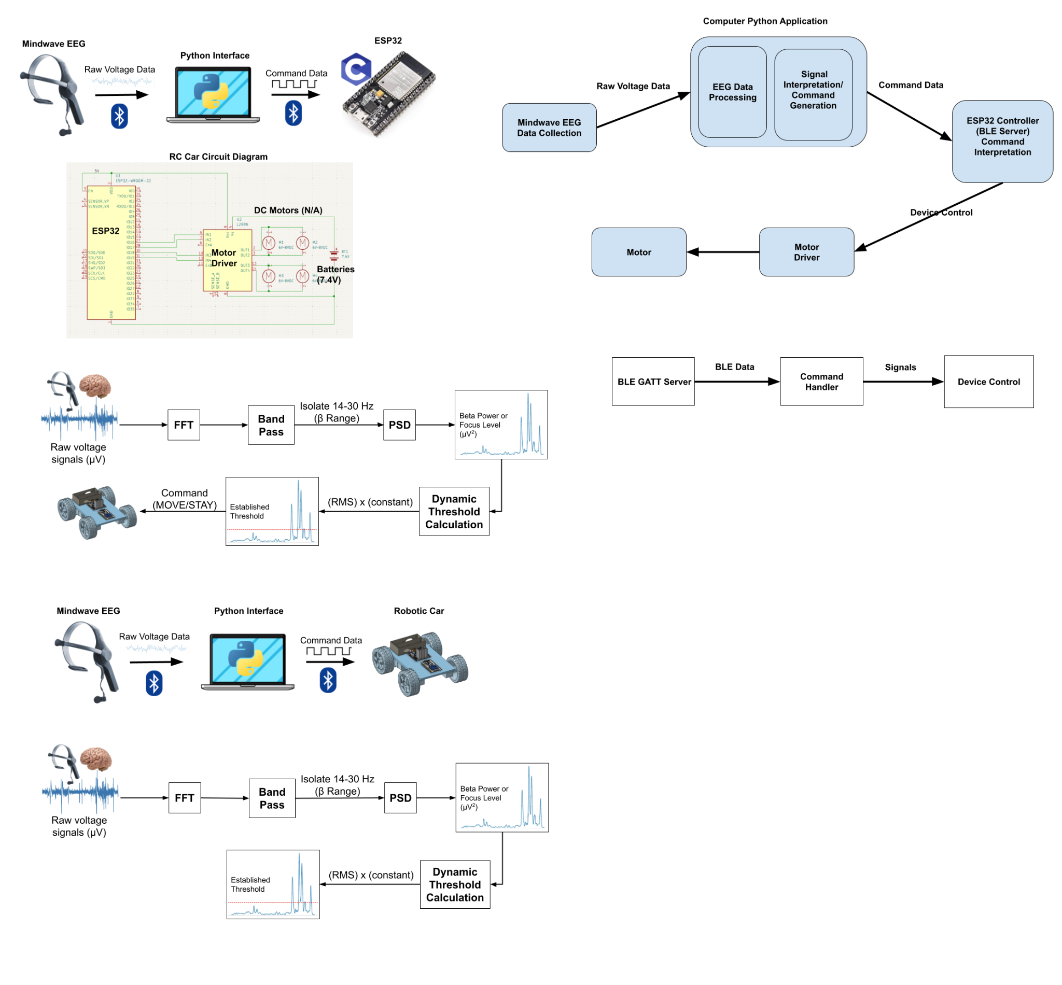

**Figure 2. Block Diagram of EEG Signal Processing System**

## Robotic Cart Hardware

The robotic cart is a four-wheel-drive platform designed to respond to commands derived from EEG signals, using the ESP32 microcontroller as its primary processing unit. The chassis, modeled in CAD and fabricated from laser-cut tempered wood for its initial prototype, supports the cart’s structural components and electronics. Its lightweight yet durable design includes dedicated locations for the ESP32, motor driver, and power supply components, with the ESP32 being near the front of the cart, the motor driver in the middle (equidistant from the wheels’ motors), and the battery holder on the back end of the cart to allocate for spacing and weight distribution. The cart operates using four DC motors, connected via a motor driver circuit as illustrated in the RC Car Circuit Diagram (Figure 3).

The ESP32 receives control signals wirelessly via Bluetooth Low Energy (BLE) from the EEG headset. These commands are converted into precise motor control signals, enabling differential power delivery for synchronized motion of the required linear (straight) movement. A stable 7.4V lithium-ion battery powers the system, with voltage regulation provided by a buck converter to ensure consistent operation. The physical assembly includes four tires mounted, initially with adhesive but eventually with metal fasteners, attached and aligned to ensure proper torque transfer and stability during operation. The cart’s chassis has been engineered to minimize friction and optimize power transfer, ensuring efficient and reliable performance. The design focuses on mechanical robustness and functionality. Its integration of precision-engineered components and thoughtful cable management makes it both reliable and maintainable, providing a strong foundation for future improvements as well as testing.

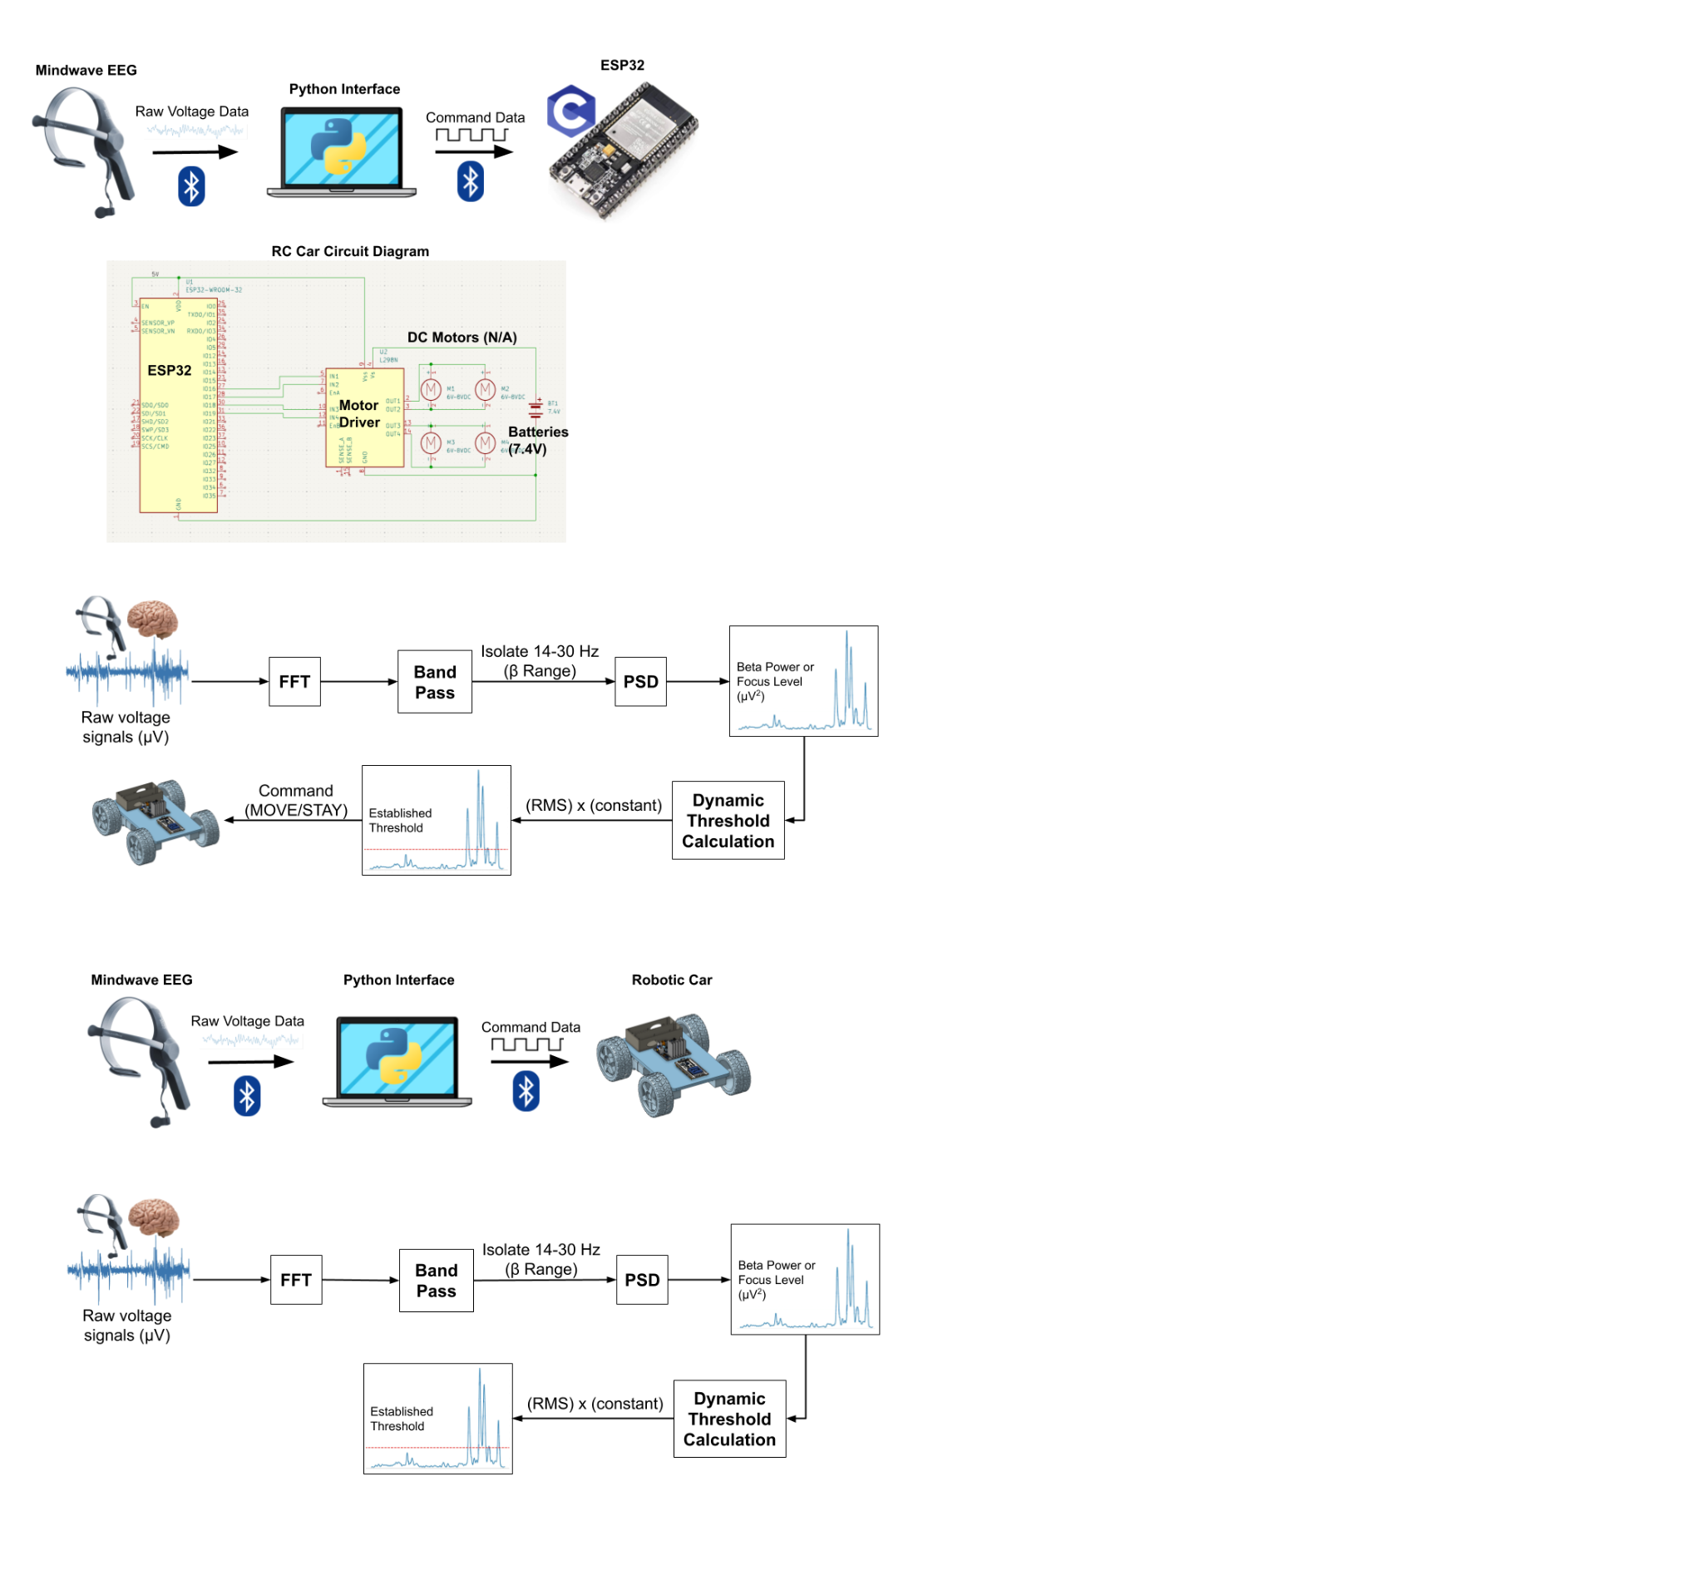

**Figure 3. Depiction of RC Car Circuit Diagram**

## ESP32 Bluetooth Integration

This system enables Bluetooth connection between a computer and an ESP32 microcontroller that acts as a Bluetooth Low Energy (BLE) Generic Attribute Profile (GATT) server, enabling control of a toy car. It uses the Bleak Python library for BLE interactions and asyncio for asynchronous communication. The system first scans for our ESP32 device, identified by the name, and establishes a BLE connection. After connecting it examines the ESP32's services and characteristics to understand the device's capabilities. This exploration involves listing all available services and their characteristics to give information on how the computer can interact with the ESP32. The system can then send messages, including commands such as "Forward," and "Stop," to a specific characteristic on the ESP32 to control the toy car's movement. It also handles notifications sent by the ESP32 which can include updates on the car's status, and displays the received data in both hexadecimal and ASCII formats for debugging purposes. The system also provides a command-line interface that allows users to manually input commands to control the car's movements in real-time specifically for testing. Another method uses a TCP server that manages the connection between the computer and the ESP32. Besides allowing for remote control of the toy car from other devices it gives the advantage of having a persistent connection between the computer and the ESP32. The persistent connection allows us to bypass the need to reconnect to the device after each test.

The ESP32 microcontroller serves as the central control unit for the toy car, receiving commands with BLE and translating those commands into actions such as forward movement, stopping, and turning. The ESP32 supports a BLE GATT server, advertising its services and characteristics, which are defined using specific UUIDs within a GATT profile. This profile provides a structured framework for data exchange between the computer, sending the commands, and the ESP32. The server manages the BLE connections, handles incoming data, and interprets the commands to control the car's motors through GPIO pins. The specific motor control functions are implemented in code, defining the logic for activating the motors in different combinations to achieve the desired car movements.

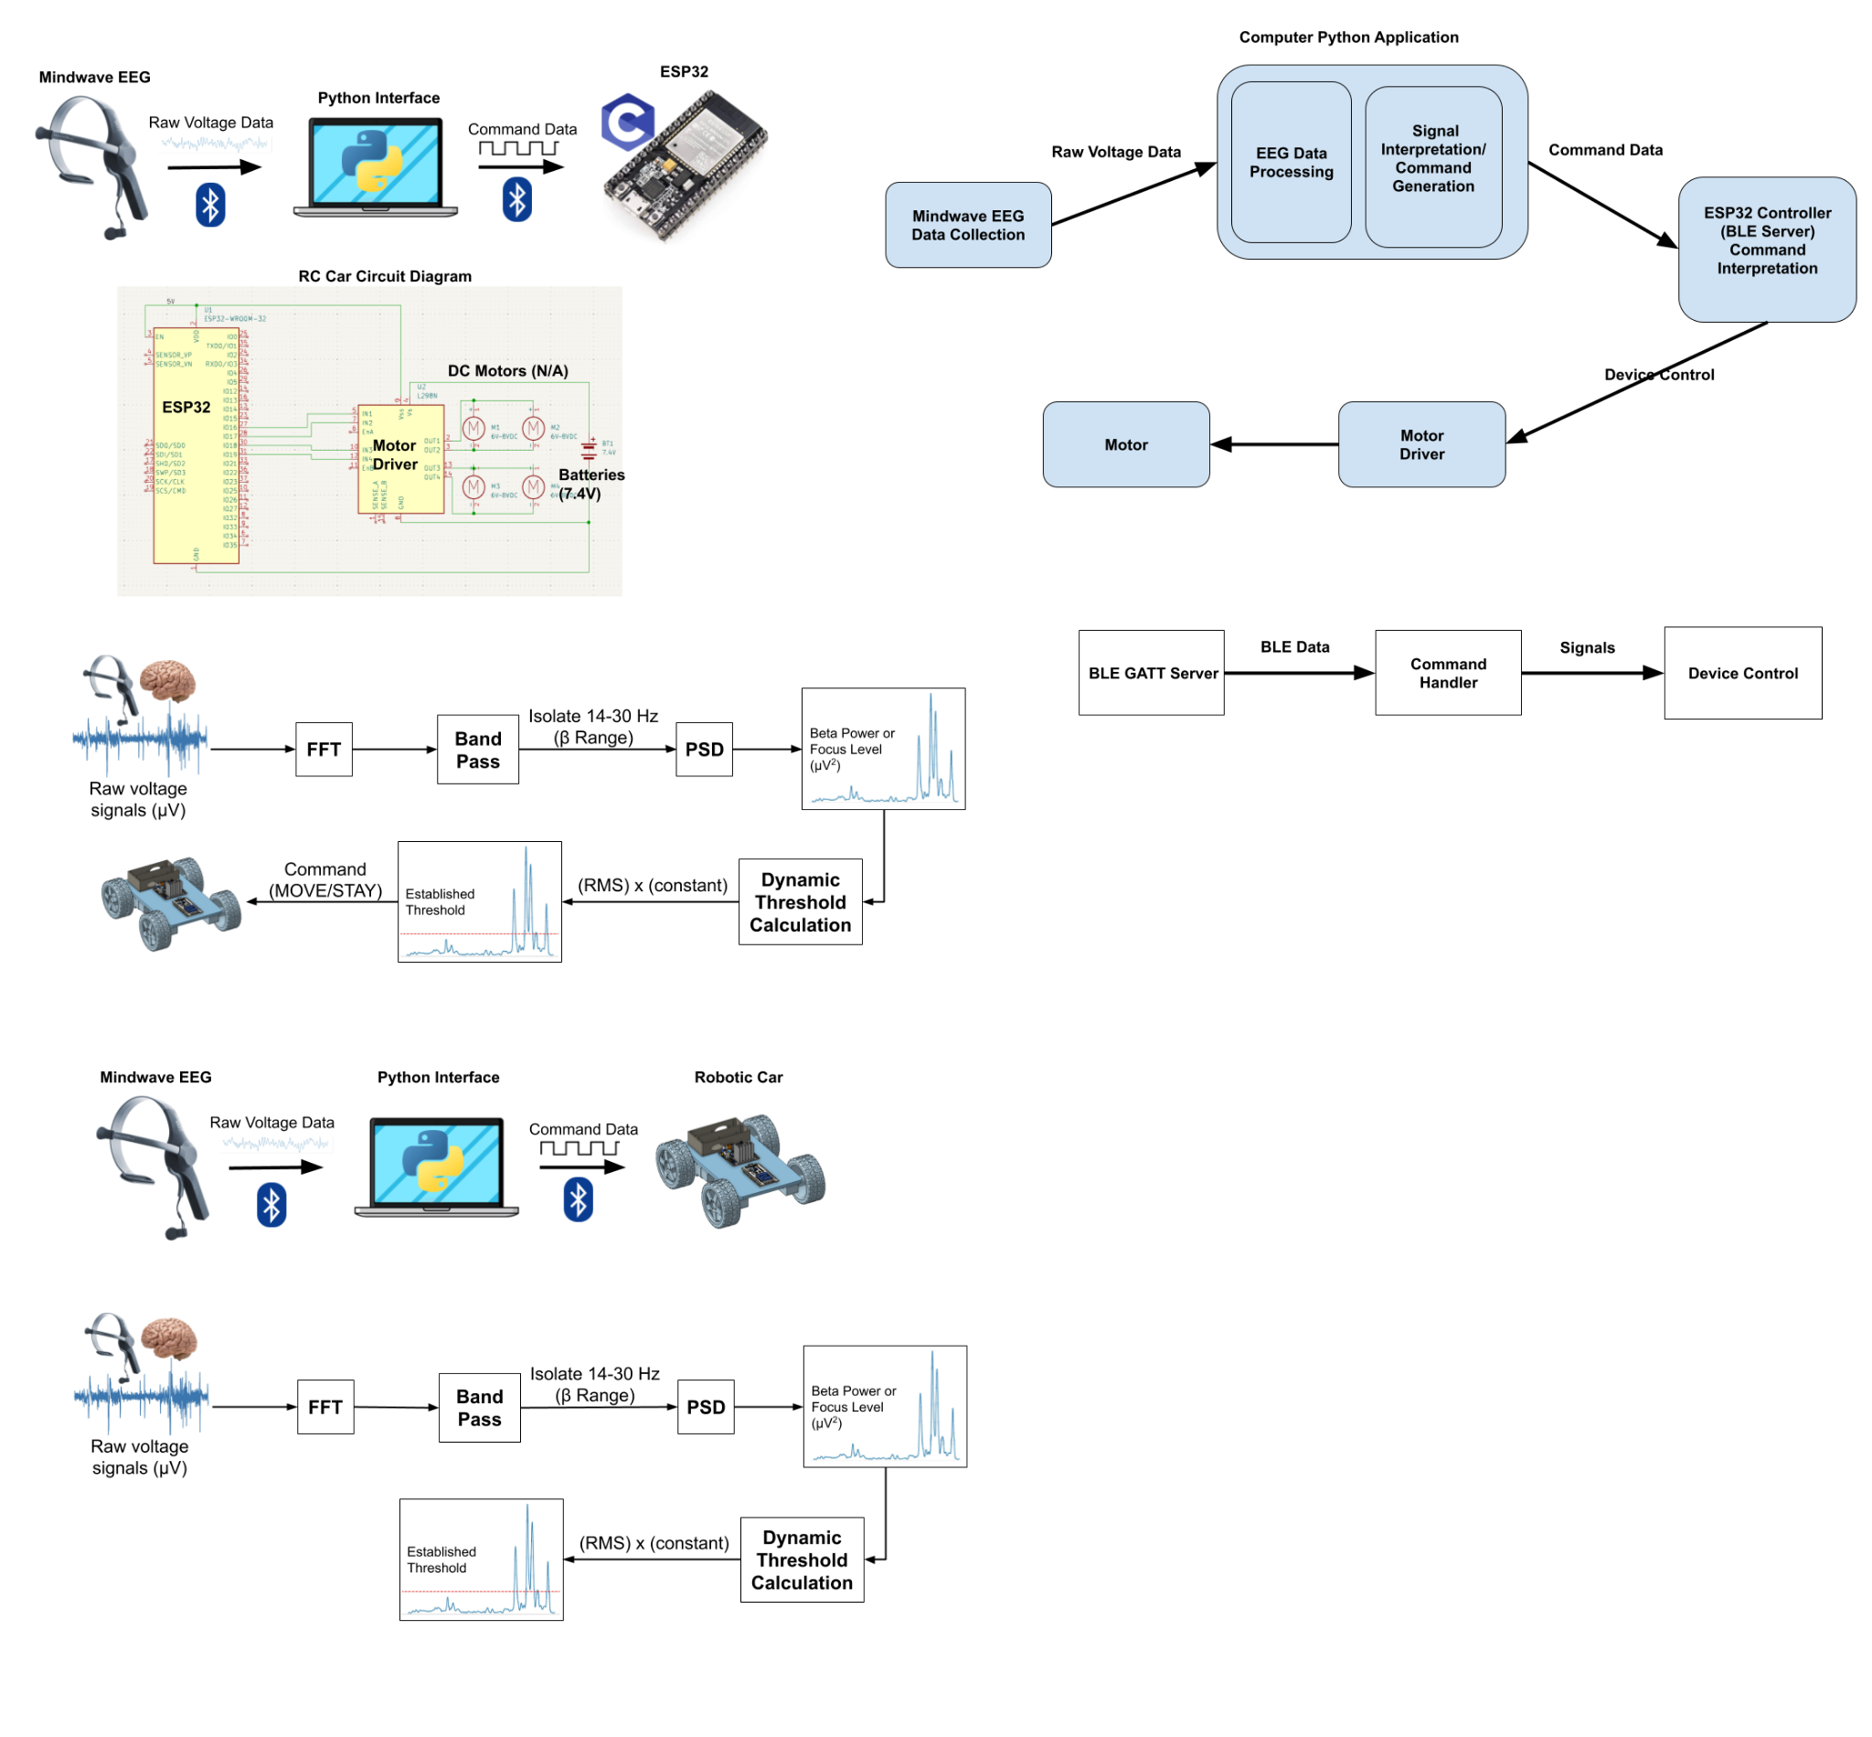

**Figure 4. Block Diagram of Internal logic of ESP32 System**

## Combining the Two Systems

Overall, by integrating the EEG signal processing system with the robotic cart hardware, the NeuroToys prototype creates a seamless interaction between brain activity and physical motion. The headgear processes EEG signals to determine focus levels, which are then transmitted wirelessly to the robotic cart via the ESP32 microcontroller. The cart interprets these signals to execute corresponding movements, showcasing a full system where cognitive intent directly drives mechanical action. This integration highlights the potential of brain-computer interface (BCI) technology in facilitating intuitive, non-invasive control over physical devices.

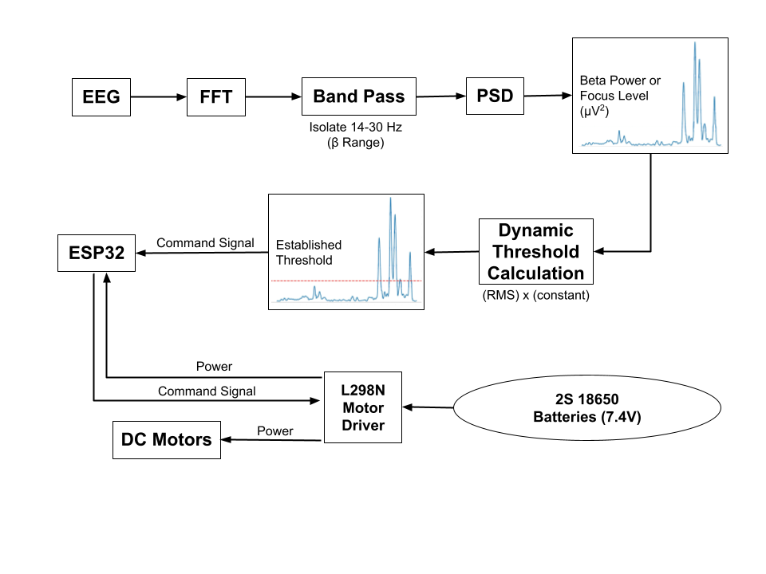

**Figure 5. Full Block Diagram of NeuroToys Prototype**

# First Semester Progress

Our team made large strides this semester, exceeding expectations for our prototype demonstration. We successfully implemented a brain-computer interface which controls an RC car remotely. Our initial goal prior to the demonstration deadline was much more modest — to wirelessly enable an LED via the EEG at a pre-specified focus threshold. However, we were able to design and verify the RC car and thus actuate the DC motors directly via the EEG. We believe this can be attributed to exceptional delegation for each task among our team, which enabled us to share our deliverables at a much faster pace, in turn fulfilling project dependencies needed to take the next step in development. Because of this, we were able to surpass our goal for this semester by driving the RC

car remotely.

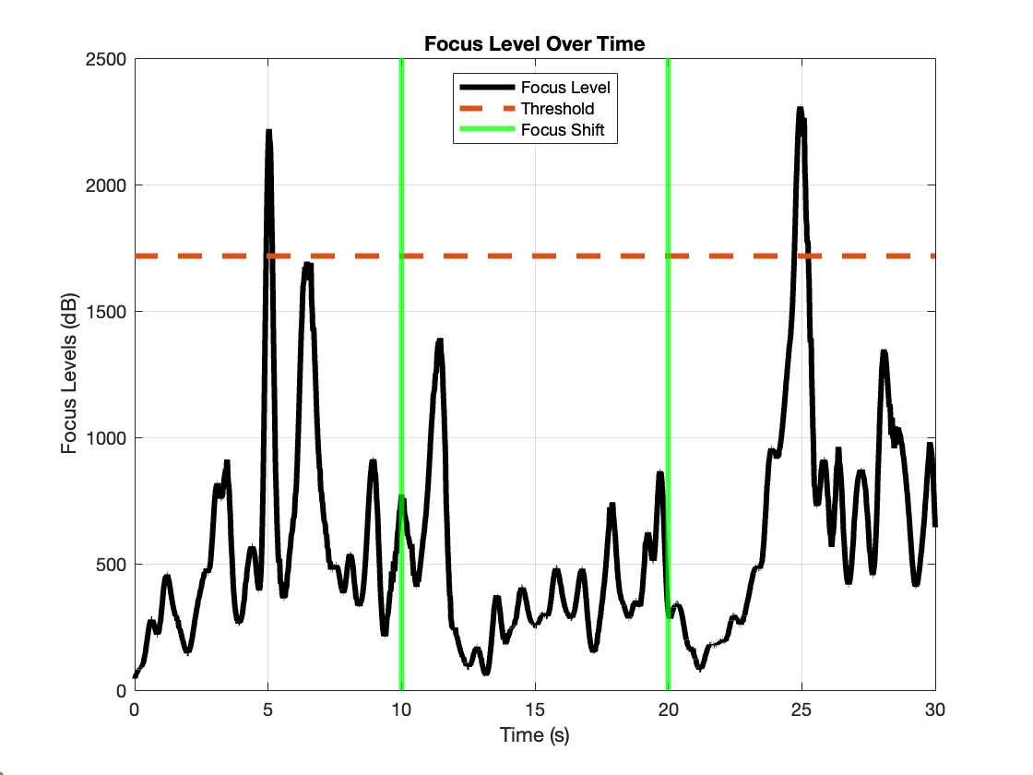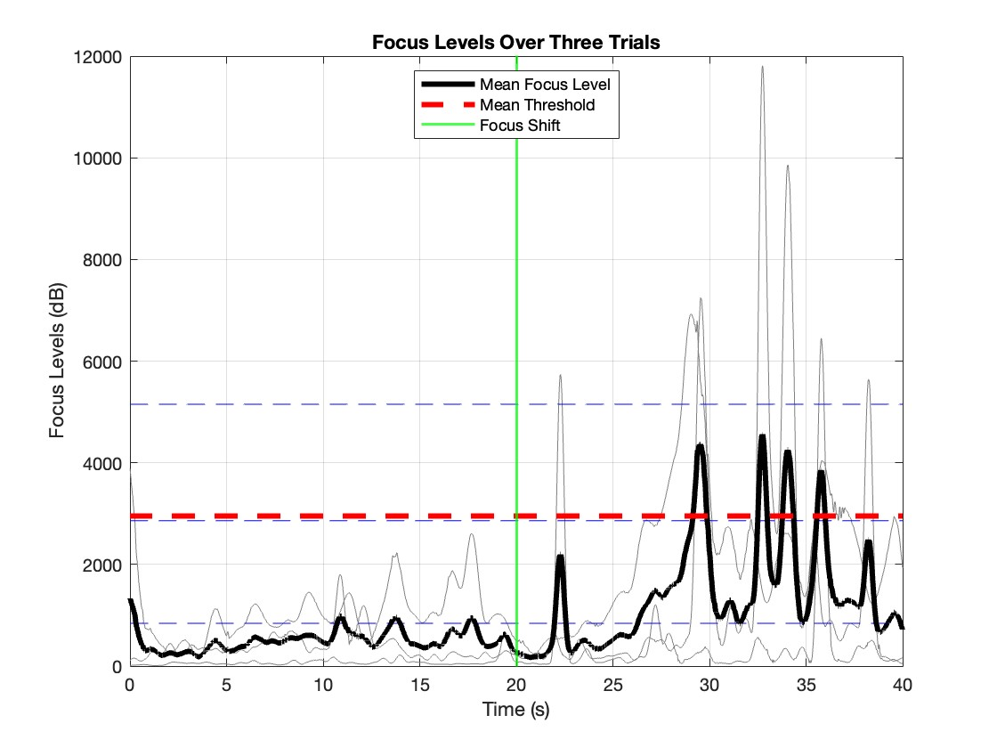

1. One trial (b) Three trial average

**Figure 6. Focus level trials with threshold**

# Technical Plan

# The following technical plan outlines a structured and detailed approach to successfully achieving the project objectives, focusing on both functionality and aesthetics. The comprehensive strategy integrates advanced machine learning, robust hardware design, and user-centric software development to create a highly efficient and innovative system. Leveraging resources such as BU EPIC, the plan emphasized precision engineering and cutting-edge fabrication techniques, including laser engraving and custom machining. Via the blending of technical rigor with creative problem solving, the plan aims to deliver a fully operational and aesthetically refined NeuroToys cart ready for functional testing and deployment.

## Multi-Classification System Development [Dec. 5 - Mar. 8]

## Replace binary classification of “Focus vs. Unfocused” with a four-category classification system: “Turn Right,” “Turn Left,” “Move,” “Stay”. Analyze existing dataset and expand annotations for the four new categories. Develop and train a machine learning model with multi-class classification algorithms. Validate the model using cross-validation and report performance metrics, such as accuracy, precision, and recall.

## Deliverable: Fully trained and validated multi-classification model ready for integration into the system.

## Lead: Gabriela; Assisting: Robert

## Enhanced EEG Interface Development [Jan. 22 - Mar. 7]

## Write updated software to bypass the legacy EEG headset connection application. Identify dependencies on legacy software. Write custom connection software to directly interface with the EEG headset. Perform functionality tests to ensure compatibility and stable performance.

## Deliverable: A functional and tested software module that replaces the legacy application successfully.

## Lead: Mete; Assisting: Adam

## GUI Development [Feb. 1 - Mar. 15]

## Implement a graphical user interface for visual parameter control and real-time signal and threshold monitoring. Design wireframes and specify GUI’s functionality. Develop GUI framework with real-time signal display and threshold adjustment controls. Conduct tests of usability and iterate based on feedback received.

## Deliverable: User-friendly GUI integrated with the system.

## Lead: Adam; Assisting: Robert

## Mechanical Updates [Jan. 22 - Mar. 1]

## Enhance the cart’s aesthetics and functionality, including material changes and branding. Design a new chassis for the cart using CAD software such as Solidworks or OnShape, incorporating the NeuroToys logo and aesthetic improvements. Select acrylic as the primary material for its durability and visual appeal. BU EPIC will be employed to assemble the new iterations and evaluate material specifications with assistance from staff. Fabricate the chassis by leveraging EPIC’s laser engraving and cutting tools to precisely cut acrylic components and engrave the NeuroToys branding onto the surface. Assemble the fabricated components to form the main housing of the cart. Develop custom metal fasteners to securely attach the cart’s base to its wheels. Use EPIC’s metalworking tools to machine and drill the fasteners into the cart’s structure. Route all electrical cables through designated housings within the chassis to ensure organization and user safety. Inspect the completed chassis for structural integrity and alignment. Test the cart under operational conditions to assess its stability, durability, and aesthetic appeal, making adjustments as necessary.

## Deliverable: A redesigned and aesthetically pleasing cart with improved functionality and integrated branding.

## Lead: Andrés

## Milestones Overview

## Completion of expanded dataset and annotations.

## Delivery of a trained multi-class model.

## Development of a functional EEG connection module.

## Creation and testing of a user-friendly GUI.

## Fabrication and assembly of an aesthetically enhanced cart chassis.

# Budget Estimate

Our project utilizes an affordable, off-the-shelf EEG and basic, low cost electronic components. In total, the cost of the prototype is $204.92, a fraction of our reimbursed budget of $750. We have succeeded in our goal of making our product a viable option for as many users as possible.

**Table 1: Prototype expenditure breakdown**

| **Item** | **Description** | **Cost** |
| --- | --- | --- |
| 1 | NeuroSky EEG Headset | $129.99 |
| 2 | 18650 Batteries (2) + Charger | $16.98 |
| 3 | 18650 Battery Spring Clip | $6.99 |
| 4 | Motor Driver | $6.99 |
| 5 | Toy Car Tires (4) + DC motors (4) | $9.99 |
| 6 | ESP32 + Breakout Board | $18.99 |
| 7 | AAA Batteries (8) + Charger | $14.99 |
|  | **Total Cost** | **$204.92** |

With the remainder of our budget ($545.08), we plan to make further improvements into the robustness of our RC car system, including the possibility of designing and ordering a custom PCB. We may also consider alternative options for our EEG for more accurate classification and lower latency connection. Given our surplus budget, we foresee no financial issues for the remainder of the development period.

# Attachments

# Appendix 1 – Engineering Requirements

Non-Invasive Brain-Computer Interface for Real-Time Robot Control

Team 9 – NeuroToys

**Table 2: Engineering requirements**

| **Requirement** | **Value, range, tolerance, units** |
| --- | --- |
| Car Dimensions | 12in x 8in x 6in maximum |
| Power | > 2 hours normal operation |
| Operating distance | > 10m from user |
| Setup time | < 5 min |
| Accuracy | > 80% classification accuracy over 5 30s trials |
| Total system latency | < 500ms |

# Appendix 2 – Gantt Chart

| **TASK TITLE** |  |  |  |  |  |  |  |  |  |  |  |  |  |  |  |  |  |  |  |  |  |  |  |  |  |  |  |  |  |  |  |  |  |  |  |  |  |  |  |  |  |  |  |  |  |  |  |  |  |  |  |  |  |  |  |  |  |  |  |  |
| --- | --- | --- | --- | --- | --- | --- | --- | --- | --- | --- | --- | --- | --- | --- | --- | --- | --- | --- | --- | --- | --- | --- | --- | --- | --- | --- | --- | --- | --- | --- | --- | --- | --- | --- | --- | --- | --- | --- | --- | --- | --- | --- | --- | --- | --- | --- | --- | --- | --- | --- | --- | --- | --- | --- | --- | --- | --- | --- | --- | --- |
| **PHASE ONE** | | | | | | | | | | | | | | | **PHASE TWO** | | | | | | | | | | | | | | | **PHASE THREE** | | | | | | | | | | | | | | | **PHASE FOUR** | | | | | | | | | | | | | | |
| **WEEK 1** | | | | | **WEEK 2** | | | | | **WEEK 3** | | | | | **WEEK 4** | | | | | **WEEK 5** | | | | | **WEEK 6** | | | | | **WEEK 7** | | | | | **WEEK 8** | | | | | **WEEK 9** | | | | | **WEEK 10** | | | | | **WEEK 11** | | | | | **WEEK 12** | | | | |
| **NeuroToys** |  |  |  |  |  |  |  |  |  |  |  |  |  |  |  |  |  |  |  |  |  |  |  |  |  |  |  |  |  |  |  |  |  |  |  |  |  |  |  |  |  |  |  |  |  |  |  |  |  |  |  |  |  |  |  |  |  |  |  |  |
| Car Design |  |  |  |  |  |  |  |  |  |  |  |  |  |  |  |  |  |  |  |  |  |  |  |  |  |  |  |  |  |  |  |  |  |  |  |  |  |  |  |  |  |  |  |  |  |  |  |  |  |  |  |  |  |  |  |  |  |  |  |  |
| Car Assembly |  |  |  |  |  |  |  |  |  |  |  |  |  |  |  |  |  |  |  |  |  |  |  |  |  |  |  |  |  |  |  |  |  |  |  |  |  |  |  |  |  |  |  |  |  |  |  |  |  |  |  |  |  |  |  |  |  |  |  |  |
| Establish Bluetooth Connection (ESP32) |  |  |  |  |  |  |  |  |  |  |  |  |  |  |  |  |  |  |  |  |  |  |  |  |  |  |  |  |  |  |  |  |  |  |  |  |  |  |  |  |  |  |  |  |  |  |  |  |  |  |  |  |  |  |  |  |  |  |  |  |
| Establish Bluetooth Connection  (EEG) |  |  |  |  |  |  |  |  |  |  |  |  |  |  |  |  |  |  |  |  |  |  |  |  |  |  |  |  |  |  |  |  |  |  |  |  |  |  |  |  |  |  |  |  |  |  |  |  |  |  |  |  |  |  |  |  |  |  |  |  |
| Signal Processing |  |  |  |  |  |  |  |  |  |  |  |  |  |  |  |  |  |  |  |  |  |  |  |  |  |  |  |  |  |  |  |  |  |  |  |  |  |  |  |  |  |  |  |  |  |  |  |  |  |  |  |  |  |  |  |  |  |  |  |  |
| Command Script |  |  |  |  |  |  |  |  |  |  |  |  |  |  |  |  |  |  |  |  |  |  |  |  |  |  |  |  |  |  |  |  |  |  |  |  |  |  |  |  |  |  |  |  |  |  |  |  |  |  |  |  |  |  |  |  |  |  |  |  |
| Integration |  |  |  |  |  |  |  |  |  |  |  |  |  |  |  |  |  |  |  |  |  |  |  |  |  |  |  |  |  |  |  |  |  |  |  |  |  |  |  |  |  |  |  |  |  |  |  |  |  |  |  |  |  |  |  |  |  |  |  |  |
| Testing |  |  |  |  |  |  |  |  |  |  |  |  |  |  |  |  |  |  |  |  |  |  |  |  |  |  |  |  |  |  |  |  |  |  |  |  |  |  |  |  |  |  |  |  |  |  |  |  |  |  |  |  |  |  |  |  |  |  |  |  |